# **SNS Assignment – III**

**Vatsal M. Nagda**

**Roll No. 20162008**

**Report On Web Vulnerabilities**

# **A1 – Injection**

**HTML – Reflection Get**

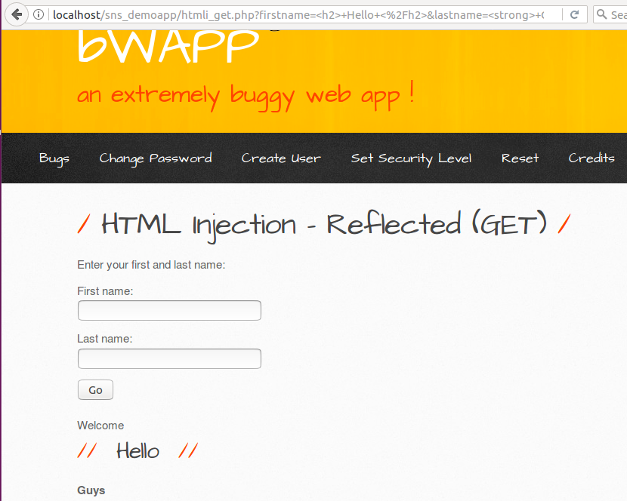

**HTML – Reflection Post**

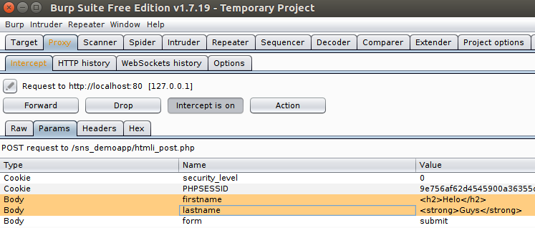



# **HTML Injection – Reflection**

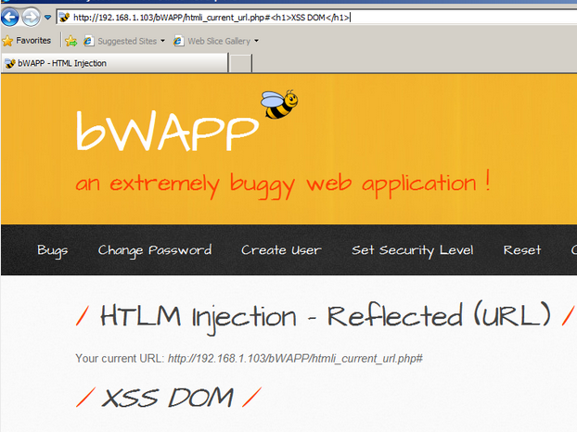

**HTML – Injection Stored**

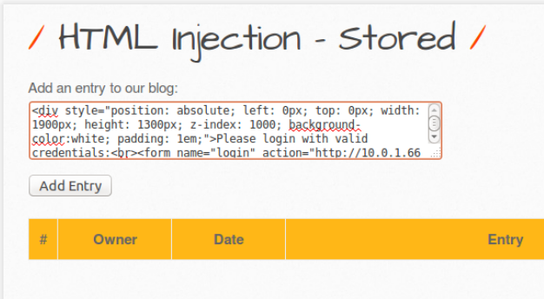

# 

# 

**I Frame Injection**

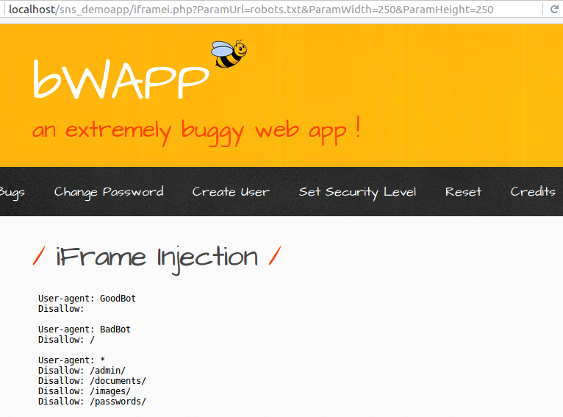

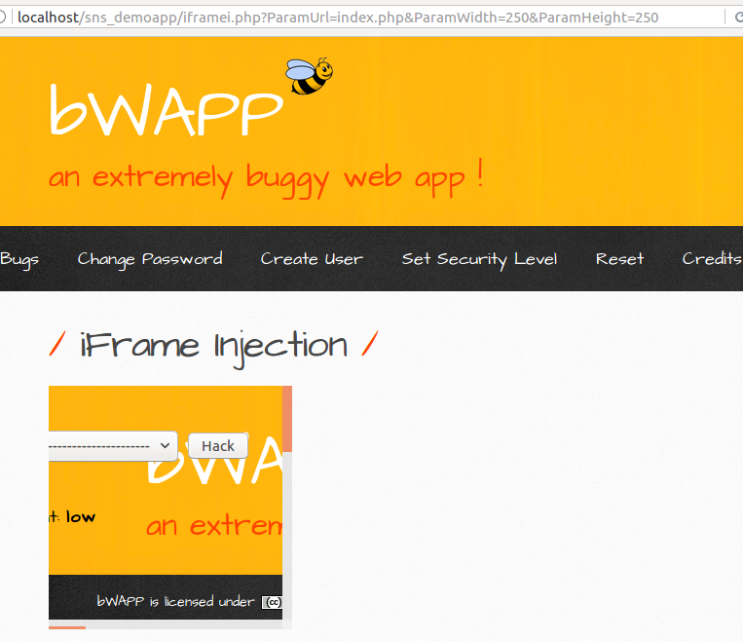

# **OS Command Injection**

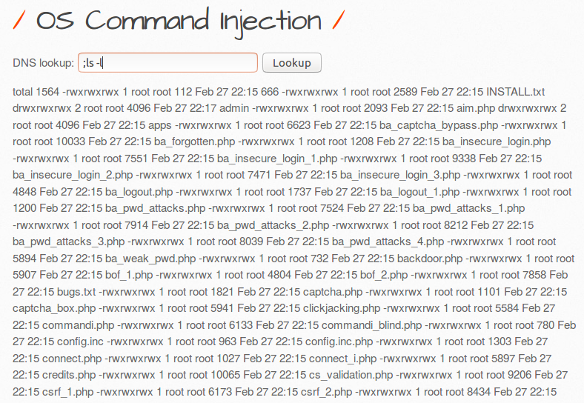

**PHP Code – Injection**

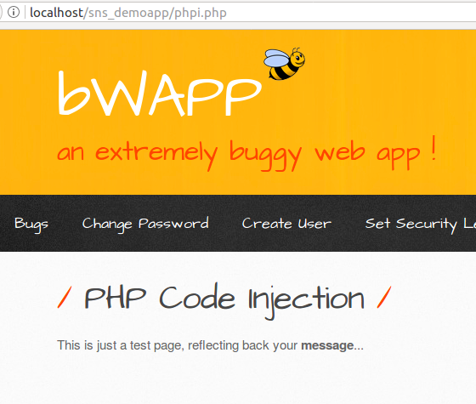

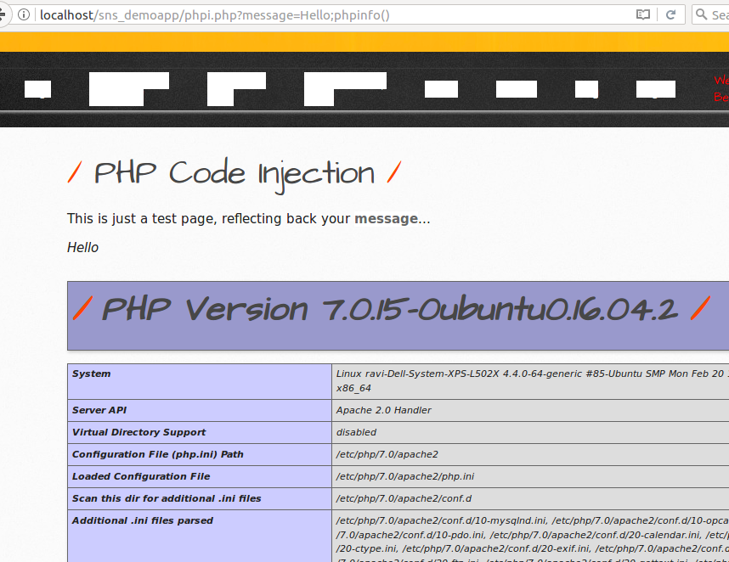

**SQL Injection Blind**

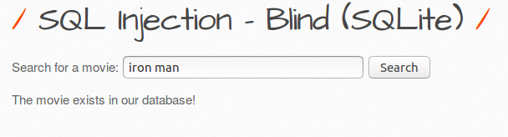

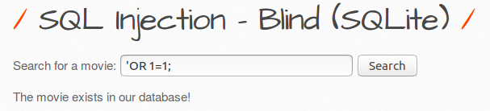

**SQL Injection (SQL Lite)**

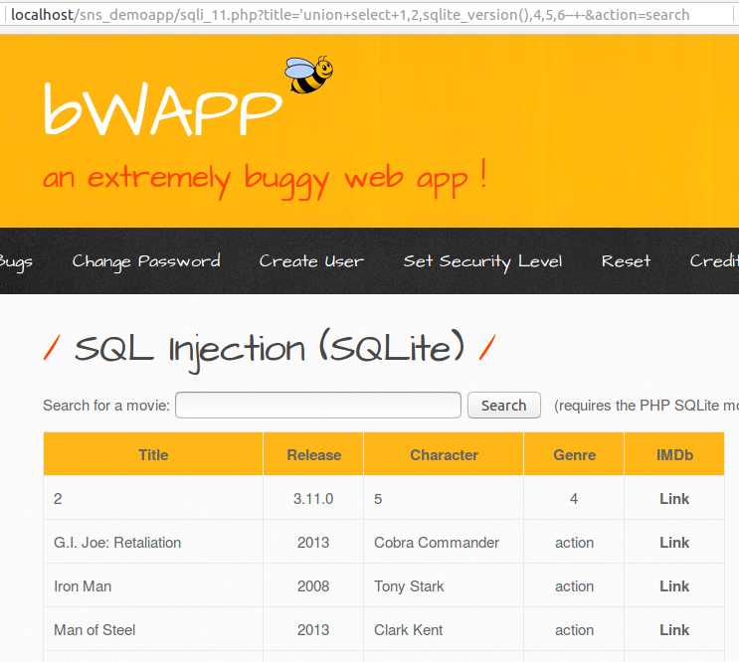

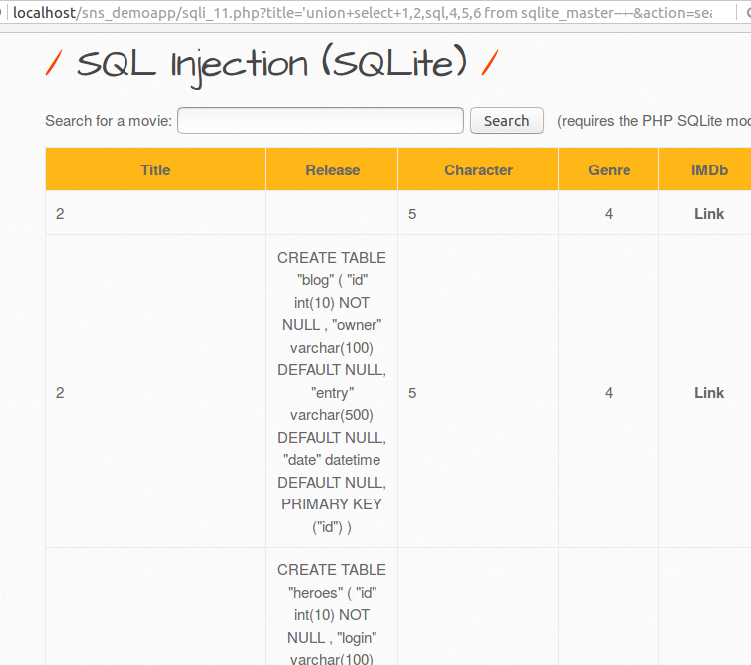

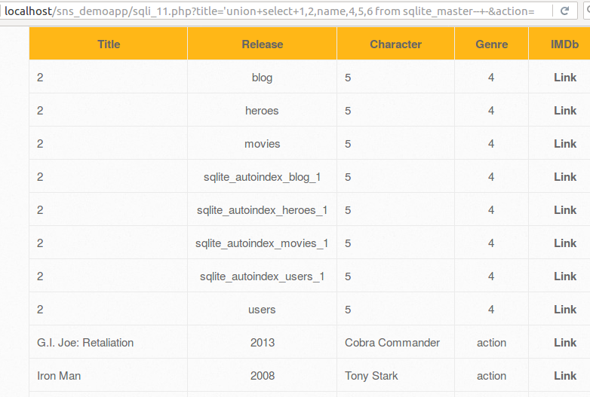

**SQL Injection Stored (Blog)**

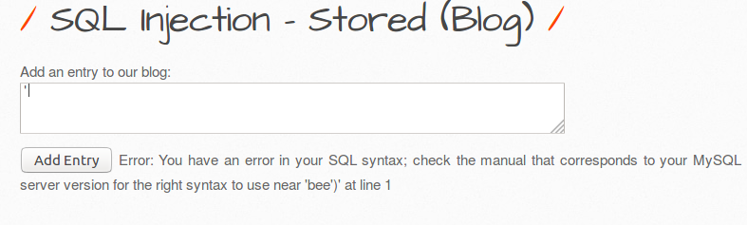

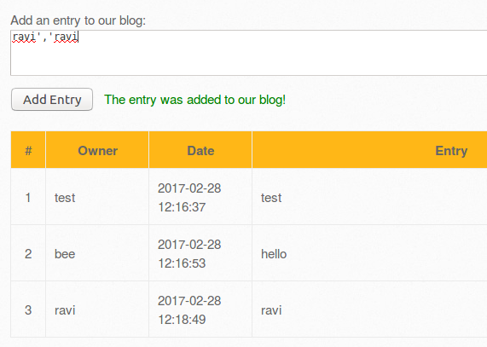

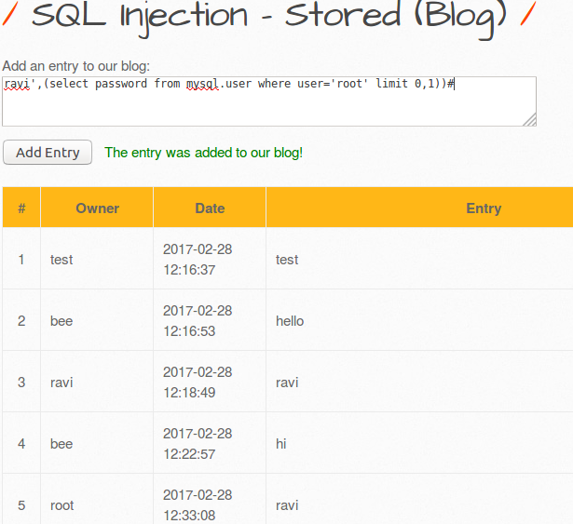

**SQL Injection Stored (SQL Lite)**

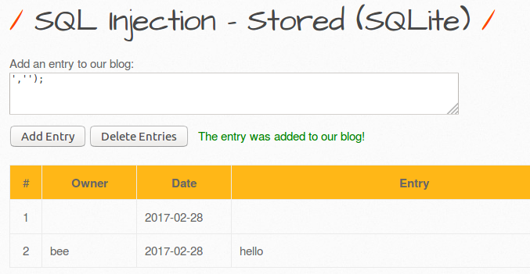

**SQL Injection Stored (User Agent)**

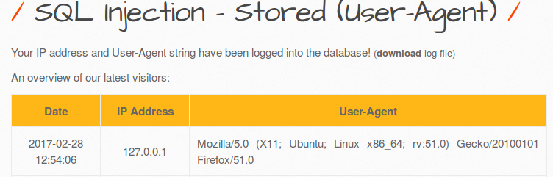



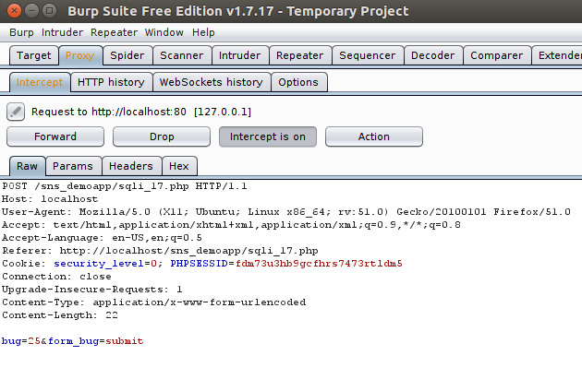

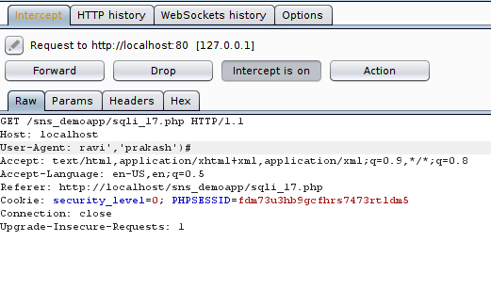

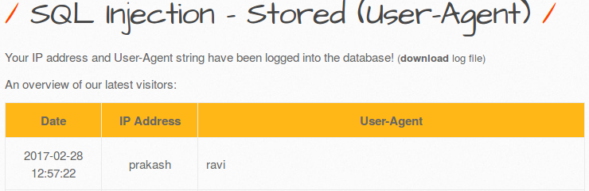

**XML XPATH Injection (Login Form)**

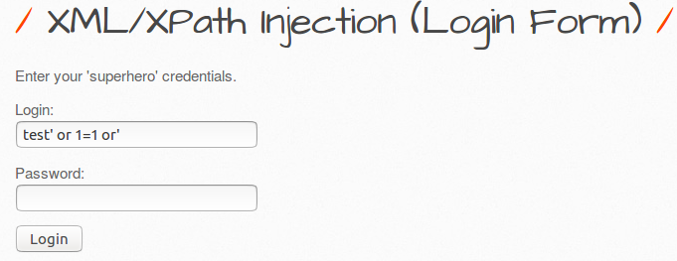

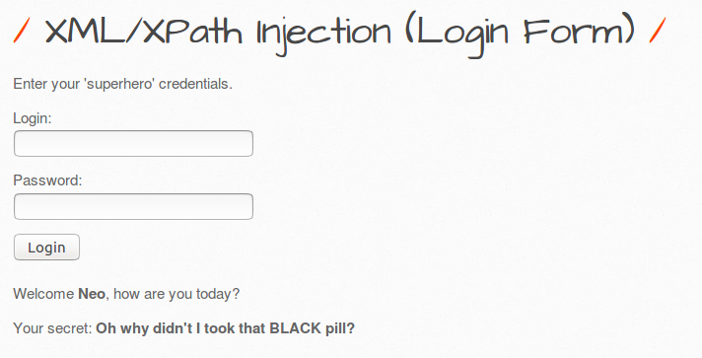

# **Fixes:**

**Html Stored Injection**

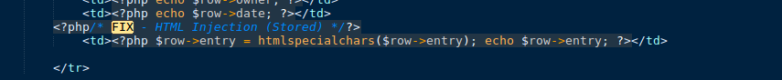

**Html Get and Post Injection**

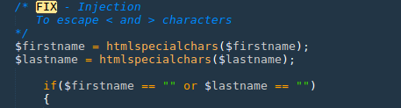

**I Frame Injection**

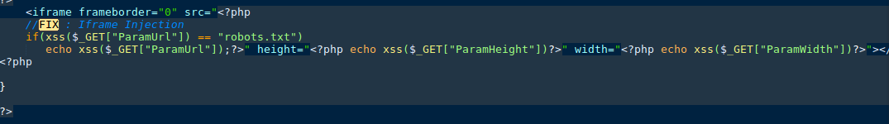

**Command Injection**

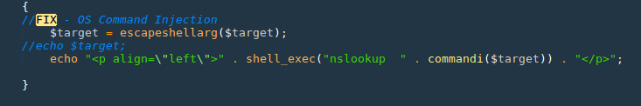

**SQL Injection Blind**

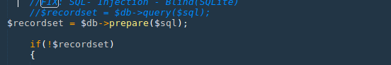

**SQL Injection SQLite**

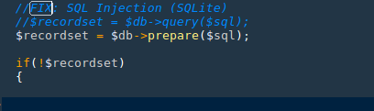

# **A2. Broken Authentication and Session Management**

# **Broken Auth. - Insecure Login Forms**

**Bug:**

1. Right click on page and view source page.
2. We can find that login: tonystark and password: I am Iron Man are by default, so if we input these values, we can successfully login.

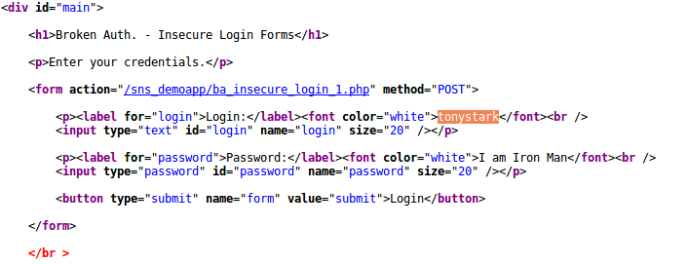

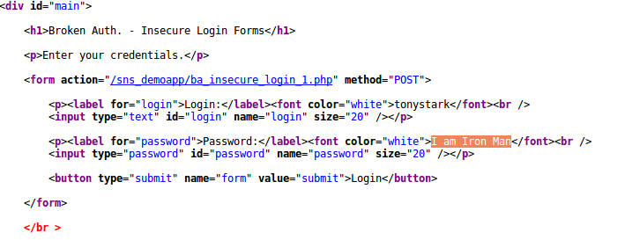

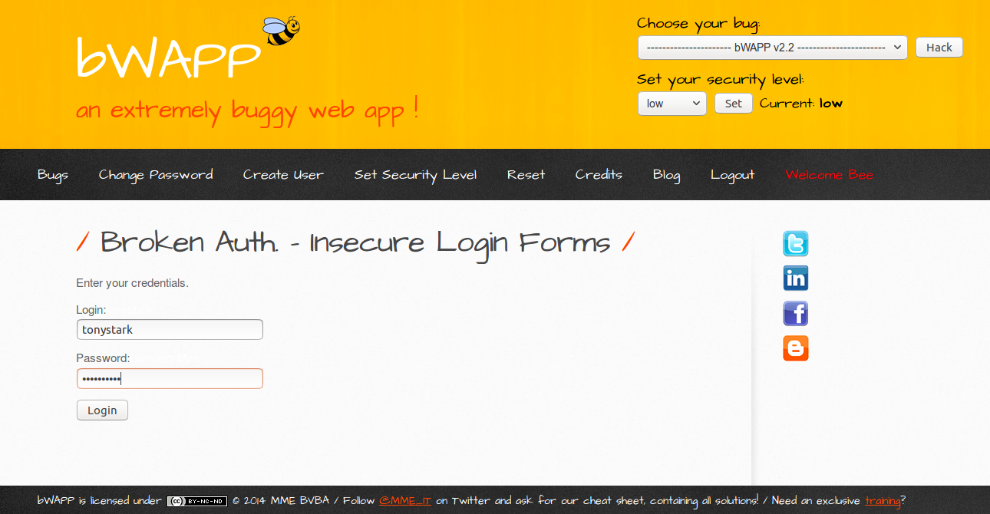

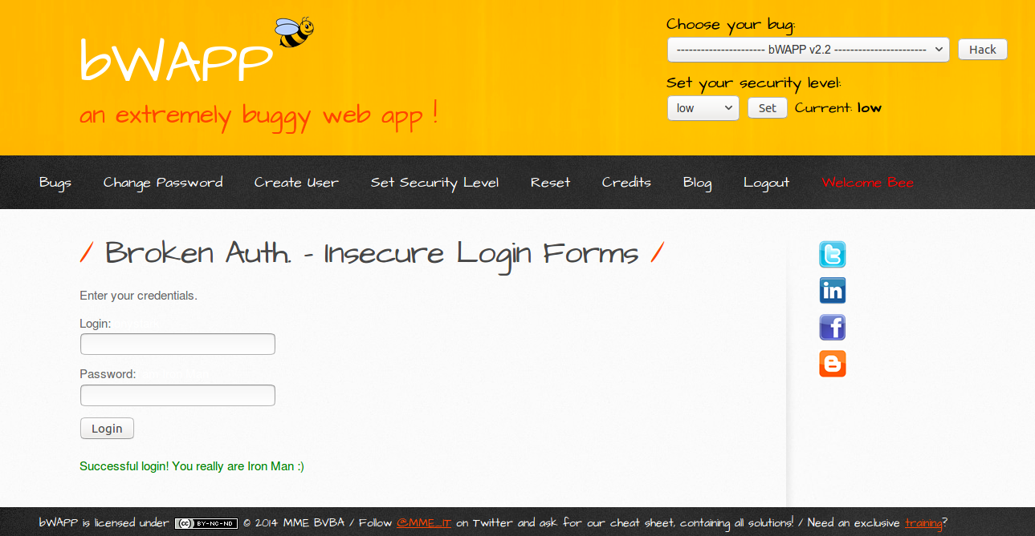

Solution:

Go to source code and remove tonystark and I am Iron Man.

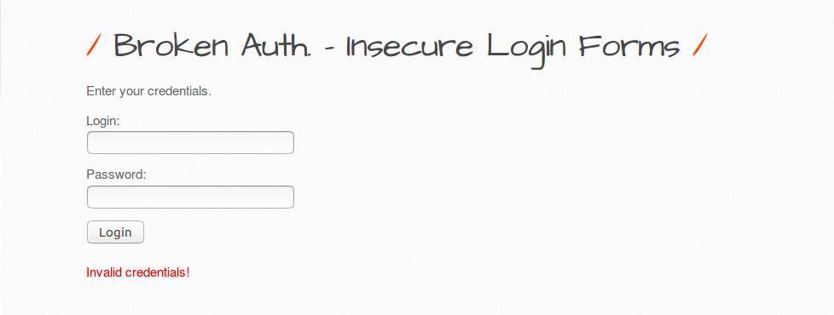

# 

# **Broken Auth. - Logout Management**

BUG: If the user as logout from the page by pressing ‘**here’.** User thinks he has successfully logged out but if some attacker presses back button it will go back to logout page as the session is not terminated.

Solution:

To add session_expired() in ba_logout_1.php so that session gets expired after successful logout.

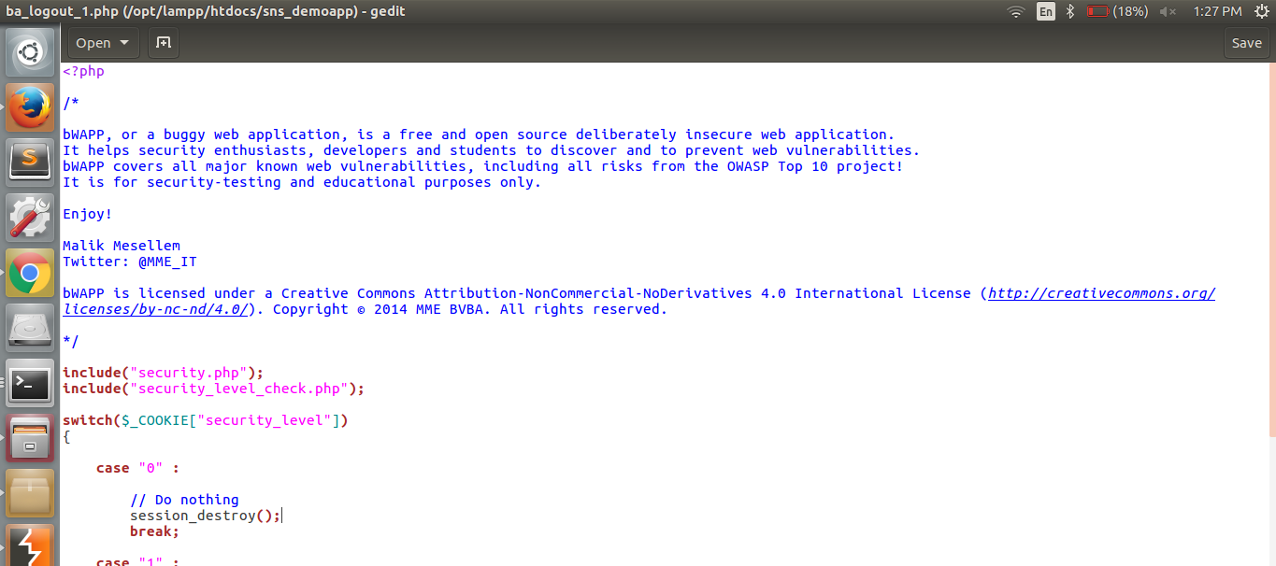

# 

# **Session Mgmt. - Administrative Portals:**

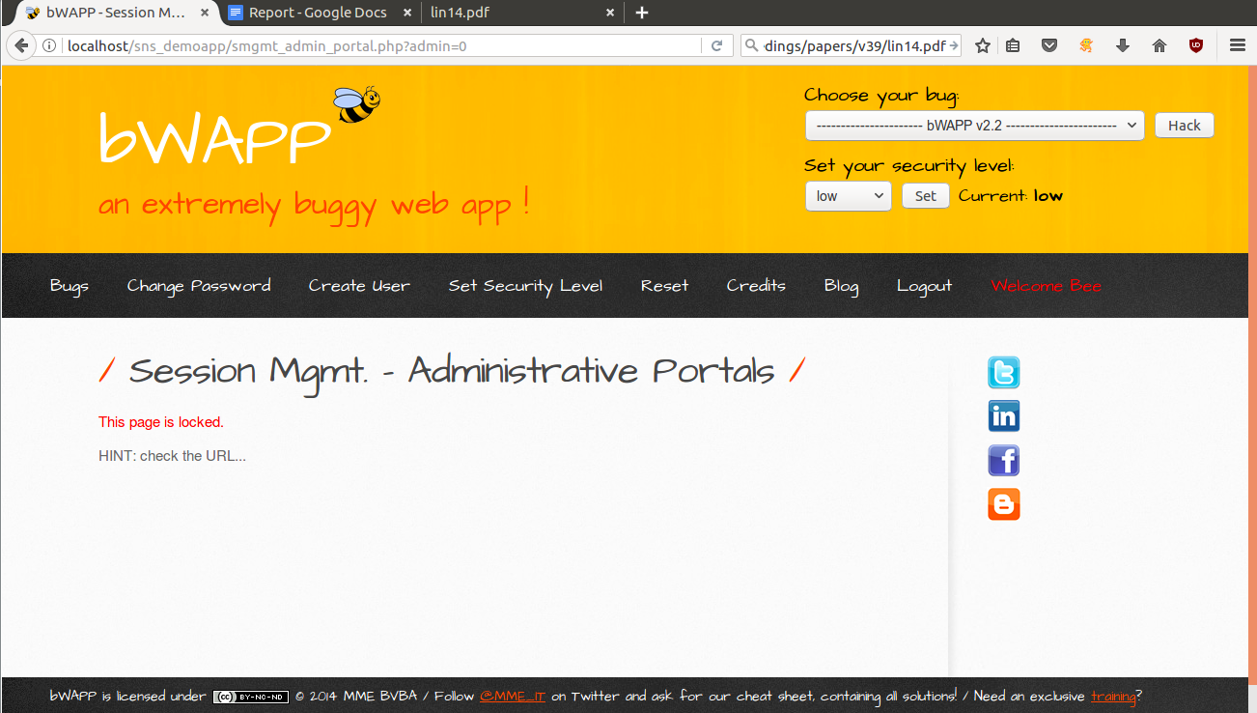

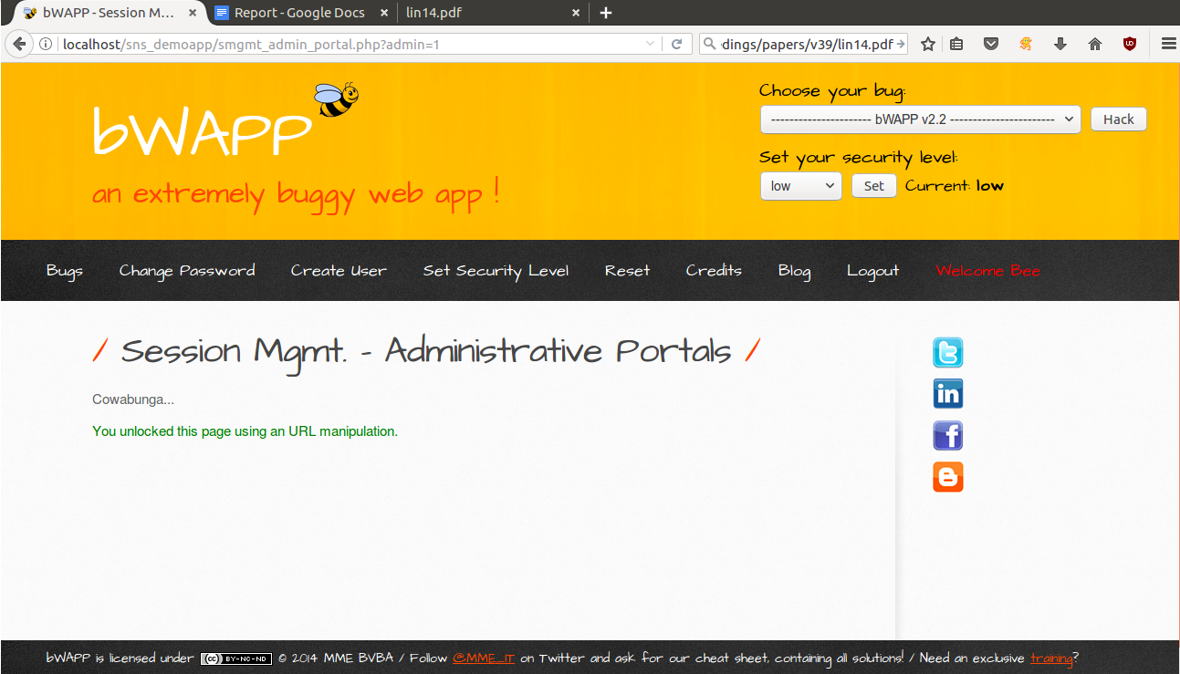

solution: We will make necessary changes in php to avoid this manipulation

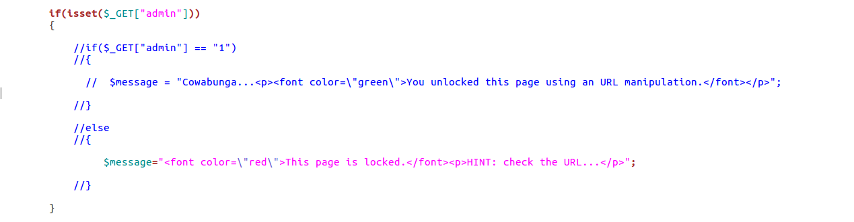

# **Broken Auth. - Password Attacks:**

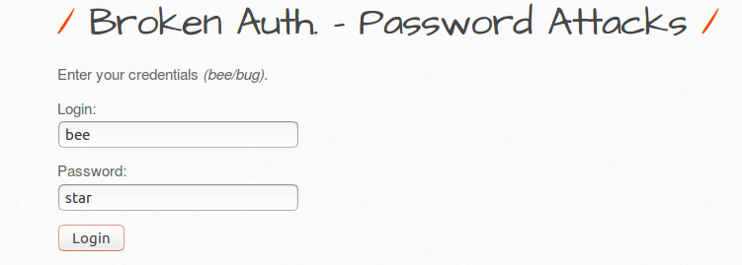

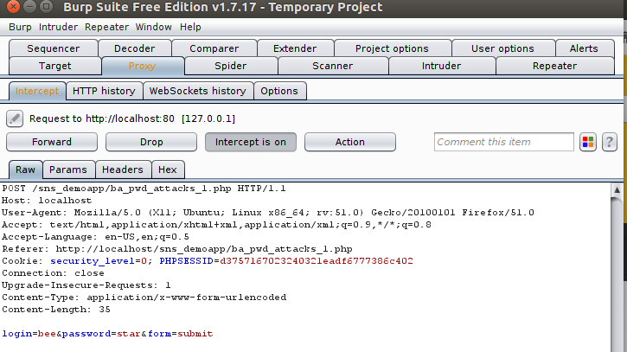

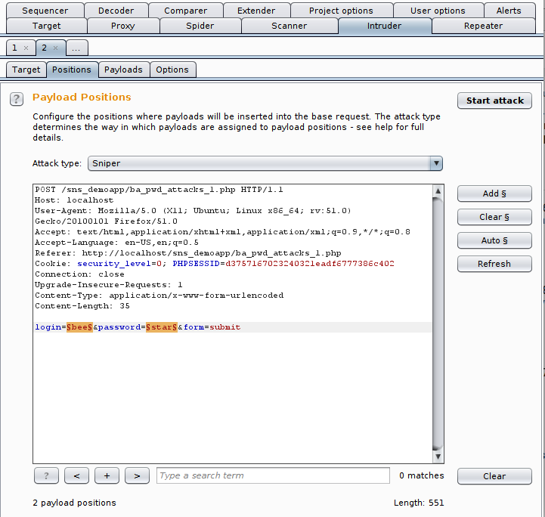

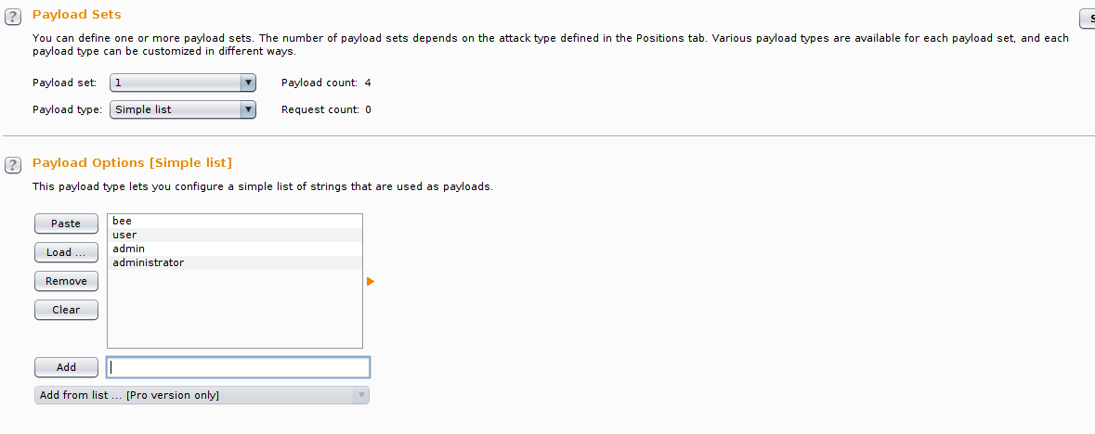

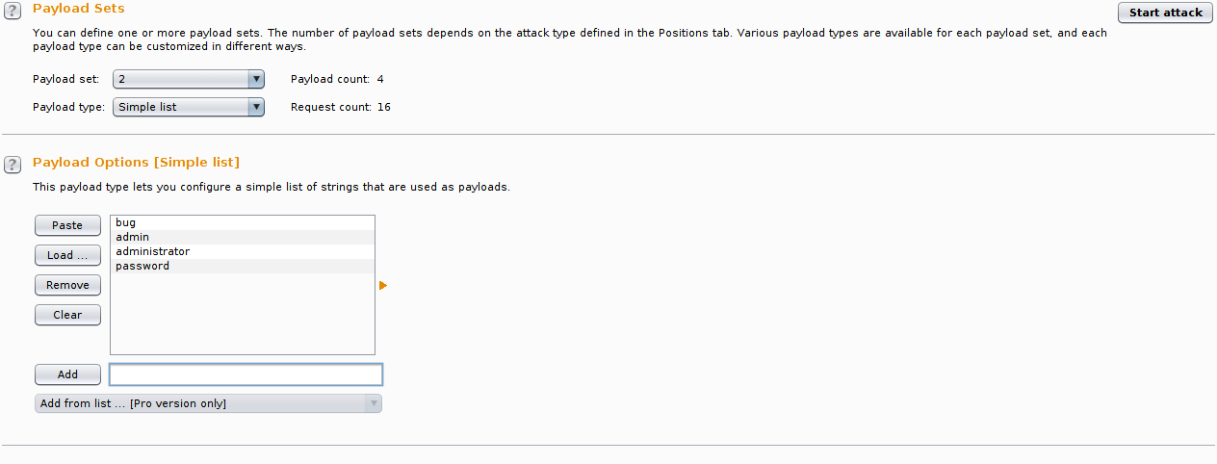

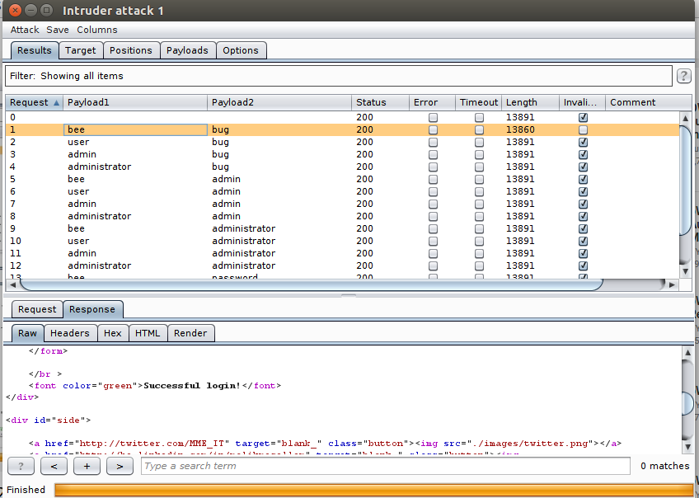

**A3 CROSS SITE SCRIPTING (XSS)**

**XSS- Reflected (AJAX)**



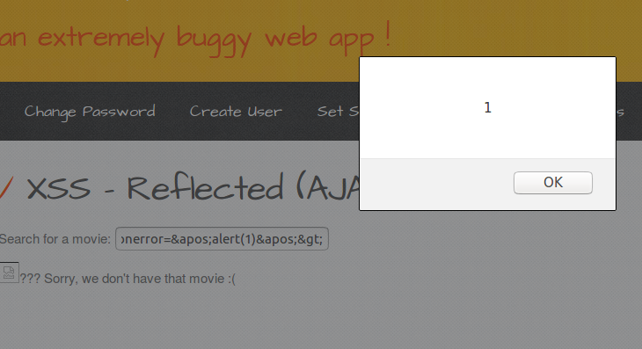

**XSS – Reflected (Custom Header)**

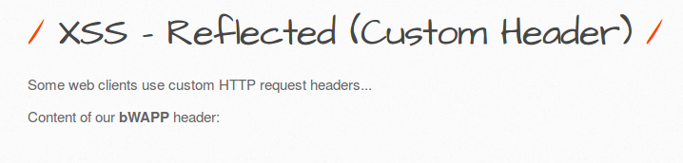

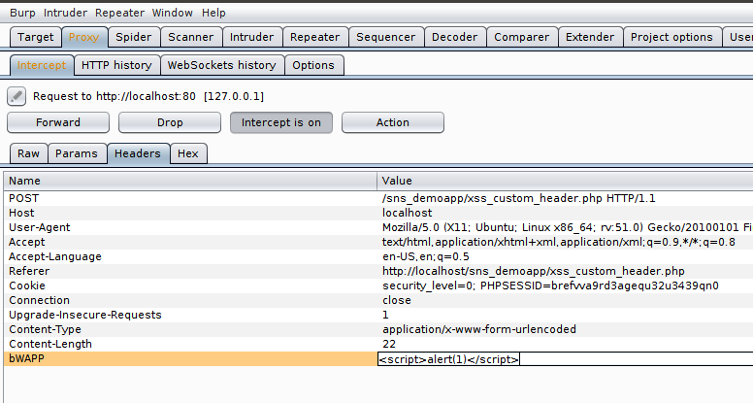

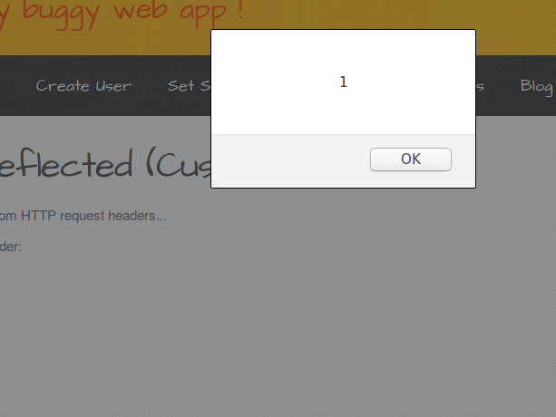

**XSS Reflected Eval**

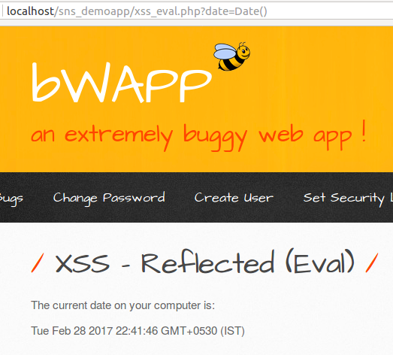

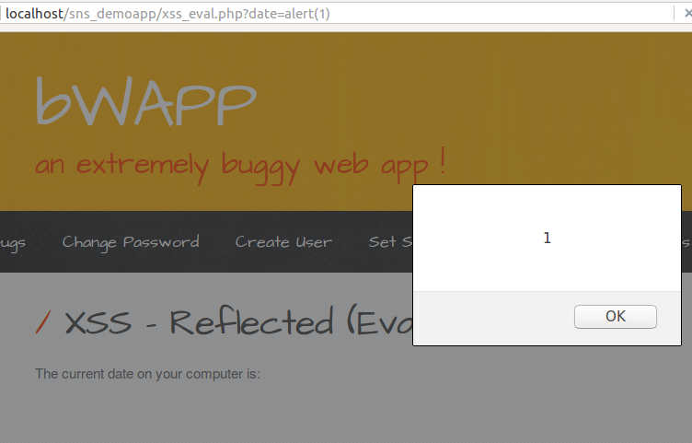

# **XSS – Reflected (AJAX/JSON)**

# 

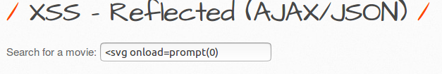

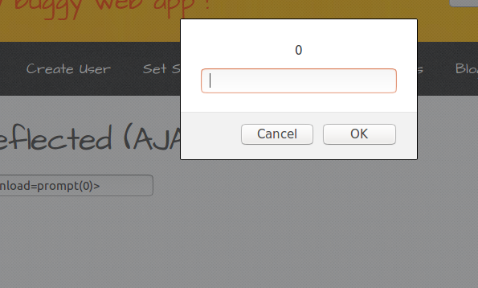

# **XSS – Reflected (Get)**

# 

# 

# **XSS Reflected JSON**

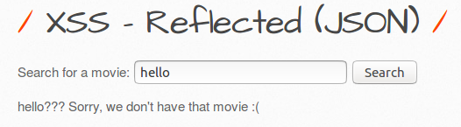

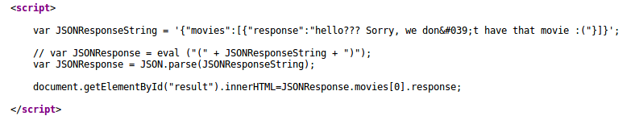

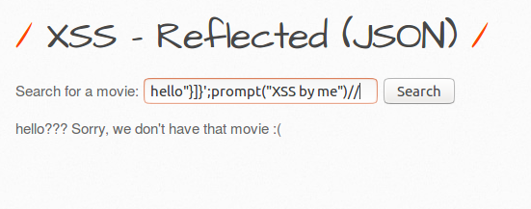

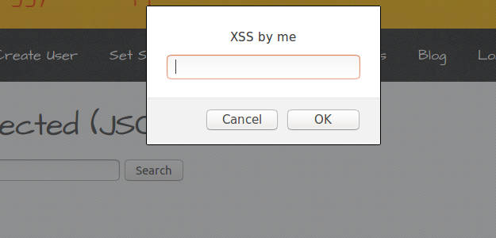

**XSS – Reflected (Post)**

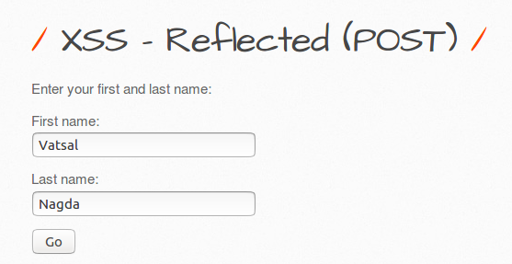

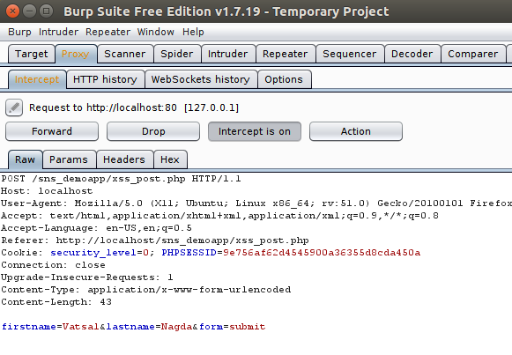

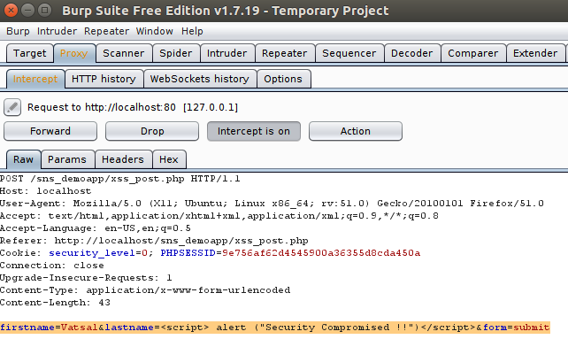

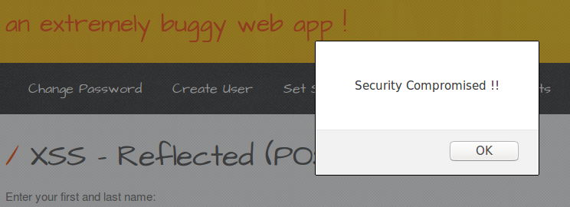

**XSS – Reflected ( User Agent )**

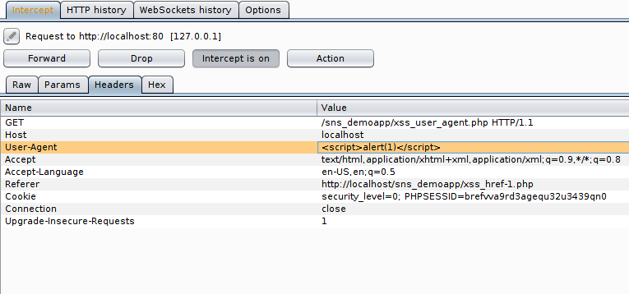

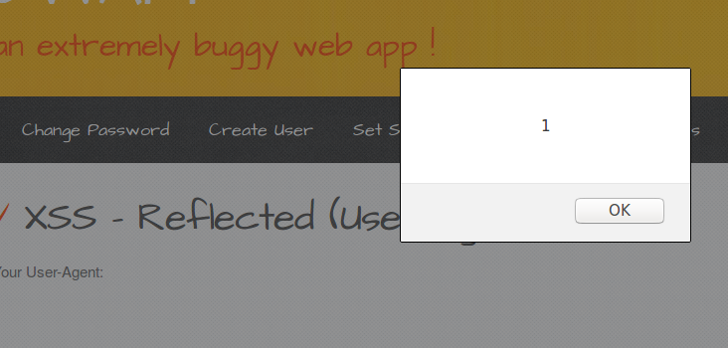

**XSS – Stored Blog**

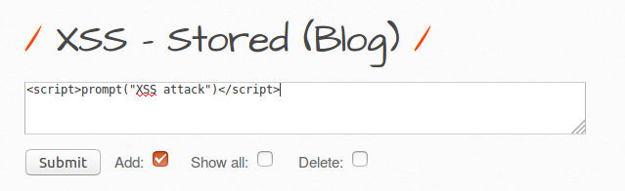

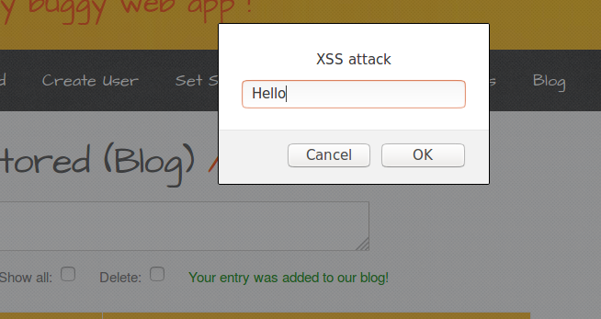

**Fixes :**

**SQL Injection SQLite**

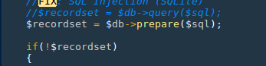

**XSS- Reflected (Customer Header)**

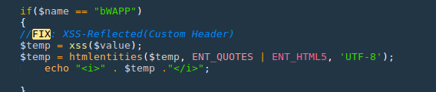

**XSS – Reflected JSON**



**XSS – Reflected (User Agent)**

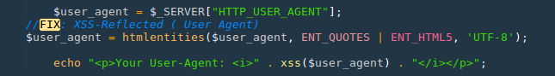

**XSS – Stored (Blog )**

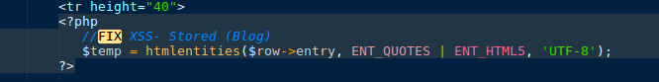

**XSS -Post**

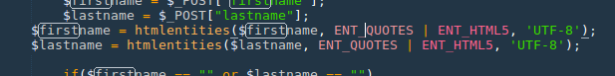

**A4 Insecure Direct Object Reference**

**a. Insecure DOR (Change Secret)**

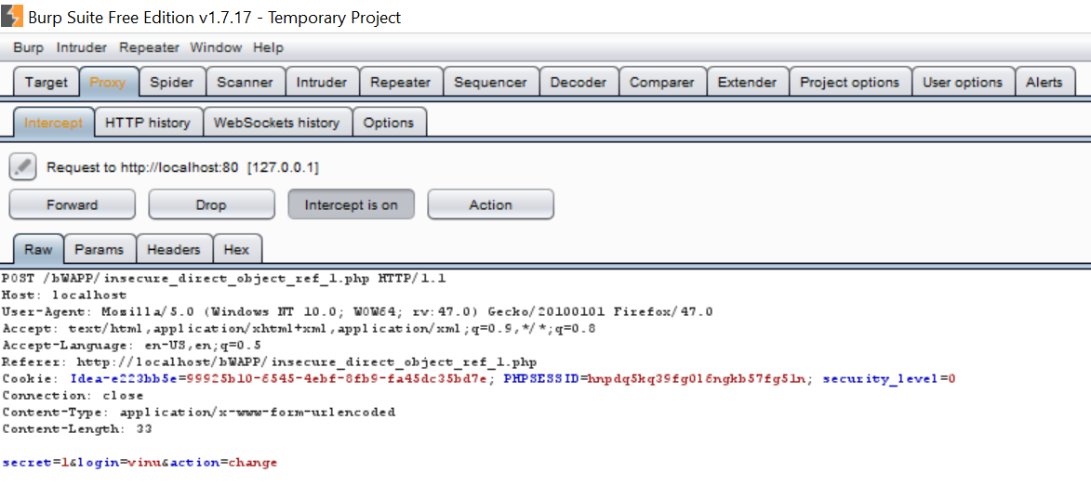

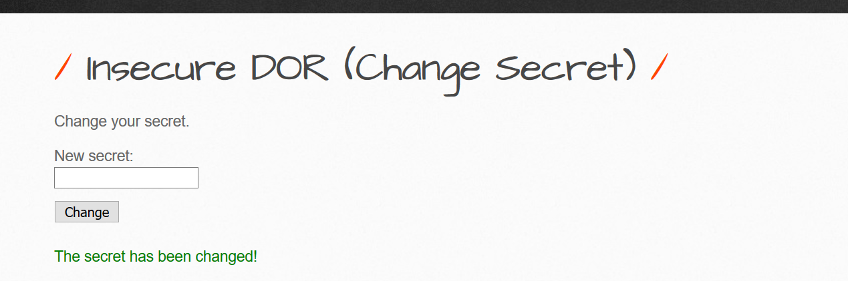

Here using third party app we can change the secret by modifying the corresponding user who has logged into the system.

**Possible Fix**

We can make a variable to store current user details if that login has been changed we can redo the corresponding changes on the login details.

If ($current_login != $login)

{

die ("Invalid User Login ");

}

**b. Insecure DOR (Reset Secret)**

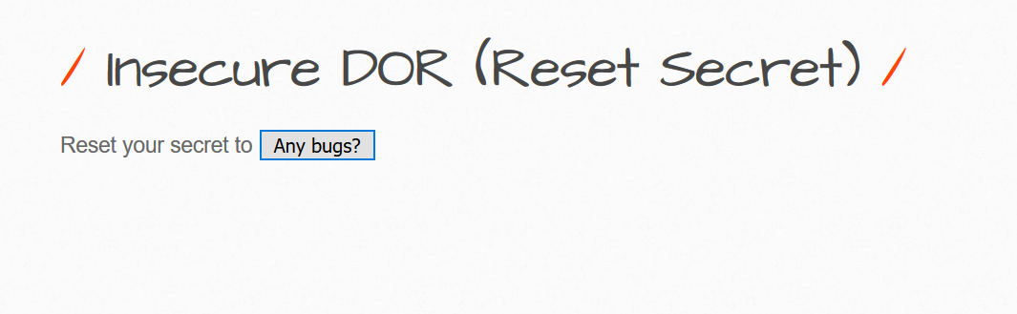

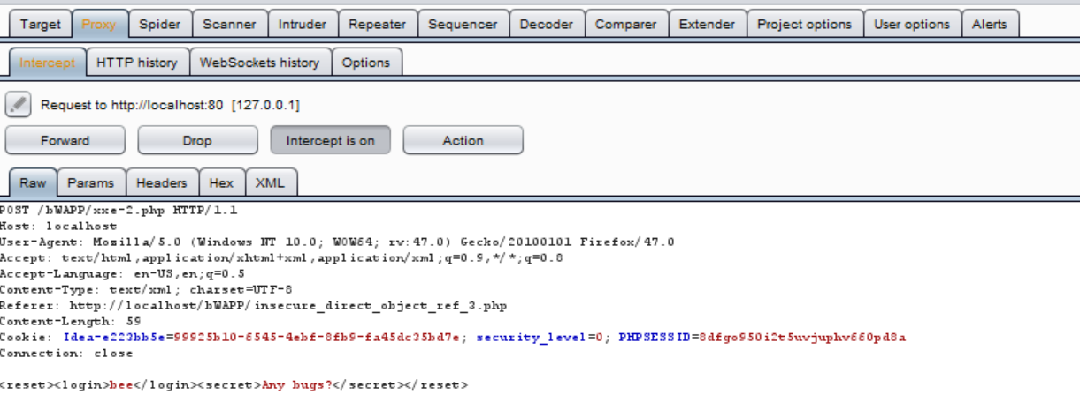

Here using the third-party app Burp we can modify the login details to something else.

Like for Example in the below Screenshot

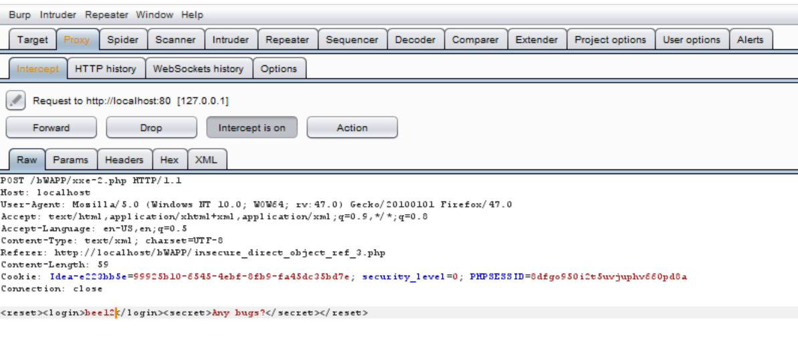

So to avoid these kind of changes made to login details. The below I have mentioned a possible Fix.

**Fix**

Like in previous case we can check if login details have been manipulated after the button click so we can modify the any changes to corresponding current user change.

If ($current_login != $login)

{

die ("Invalid User Login ");

}

**c. Insecure DOR (Order Tickets)**

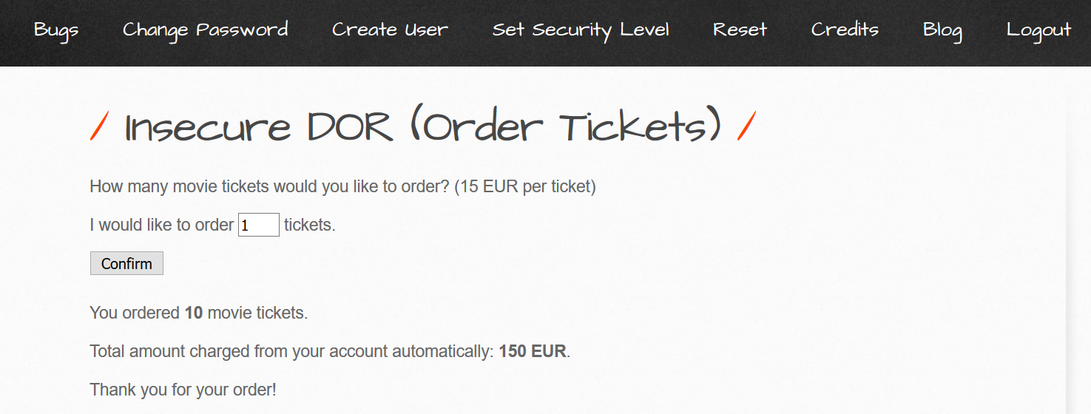

Here Each ticket price cost 15 EUR so for 10 Tickets it will cost 150 EUR but attacker

Can change cost for each ticket.

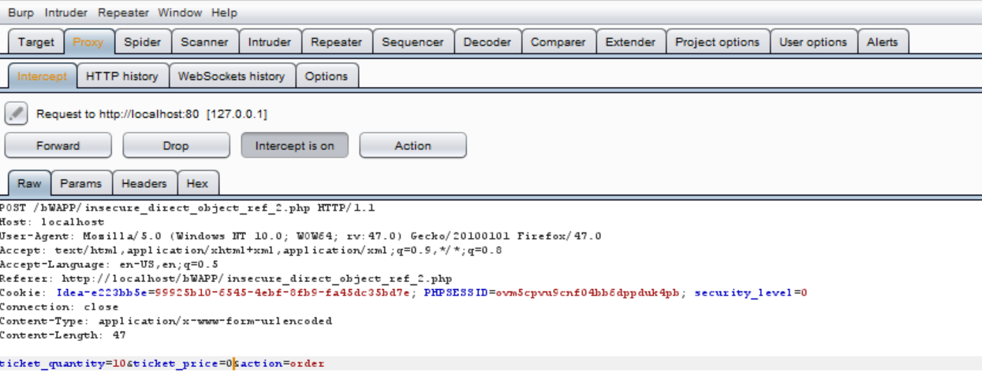

Here attacker has modified the ticket Price from 15 EUR to 0 EUR.

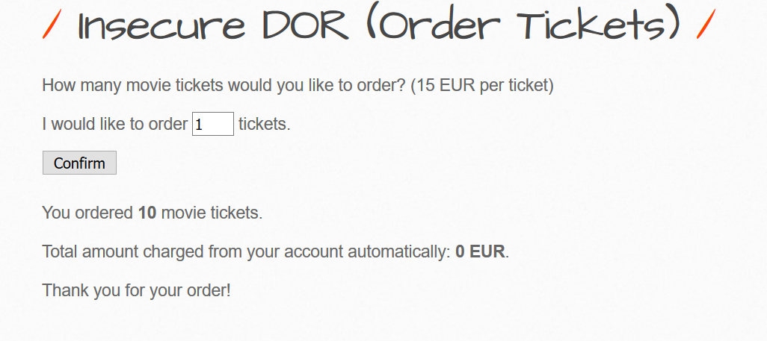

So to avoid these type of attack on objects storing some important values to be manipulated

**Fix**

We can store the price for ticket some value which is global constant and check if ticket price has been modified if so we can change the ticket price to original value.

if($ticket_price != 15)

{

$ticket_price=15;

}

# **A6. Sensitive data exposure**

# **Base64 Encoding (Secret)**

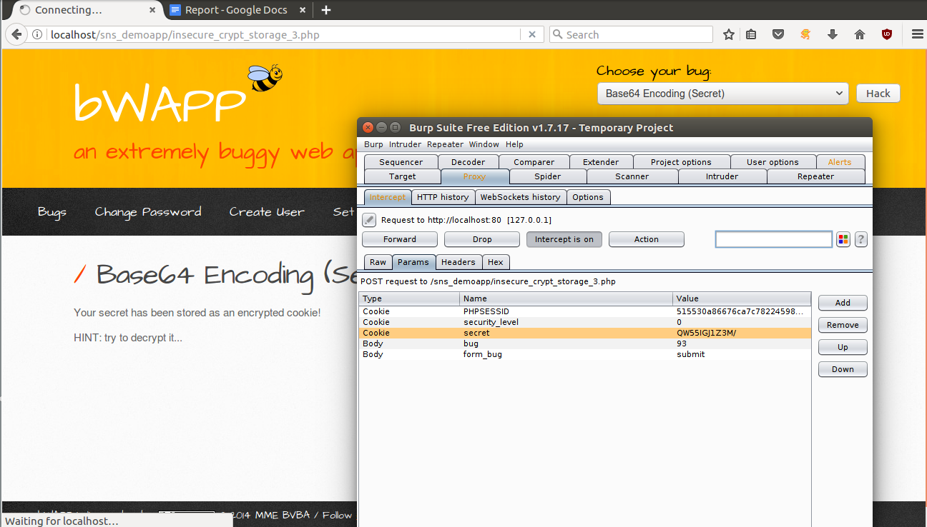

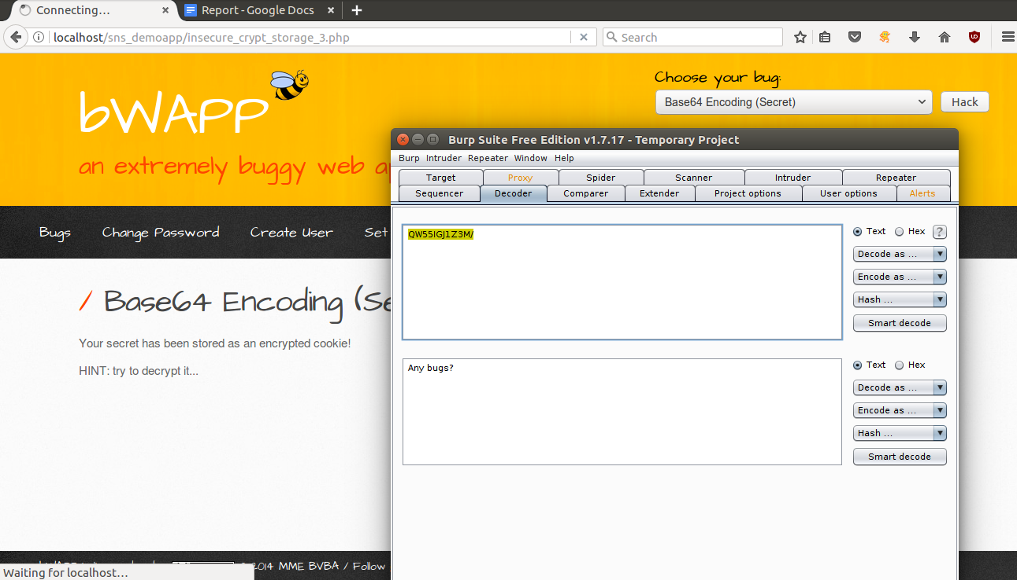

**A7 – Missing Functional Level Access Control**

**Directory Traversal - Files**

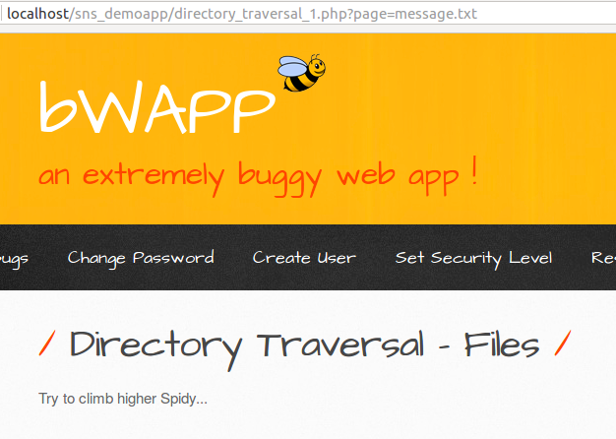

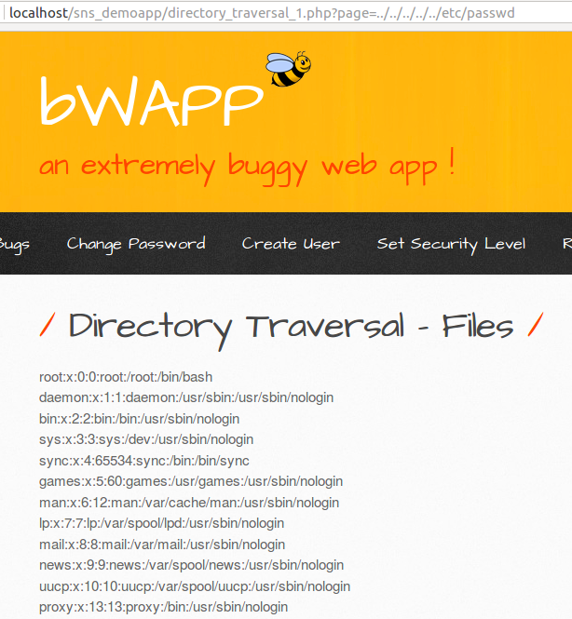

**Directory Traversal – Directories**



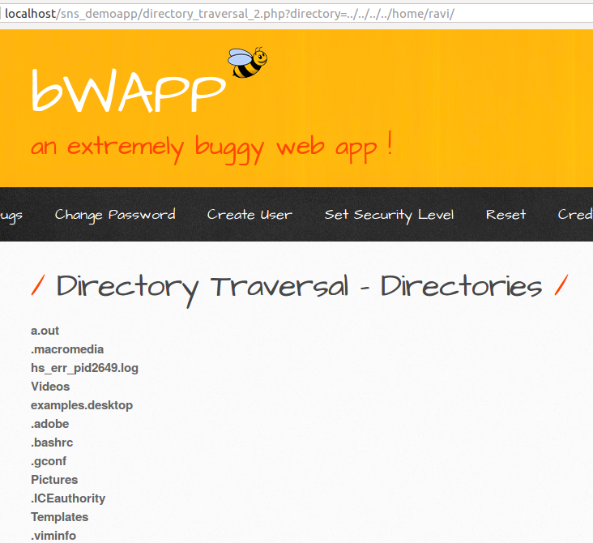

**Host Header (Cache Poisoning )**

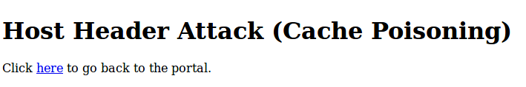

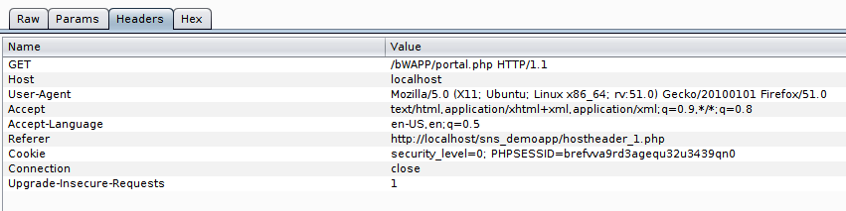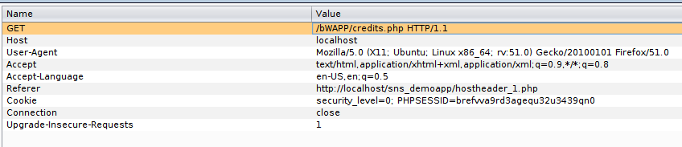

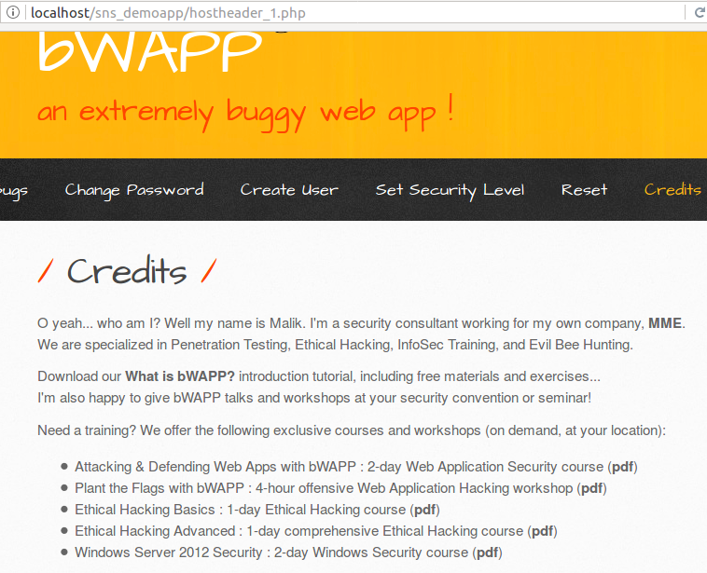

**Remote and Local File Inclusion**



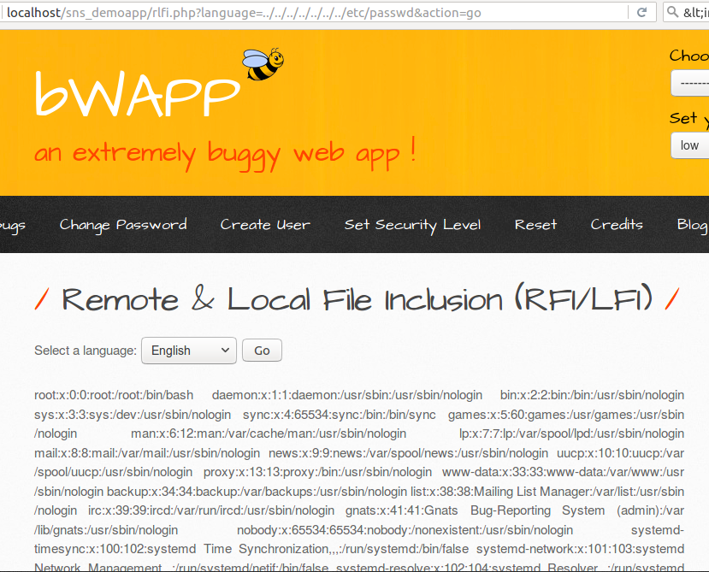

**Restricted Device Access**

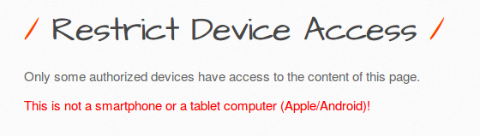

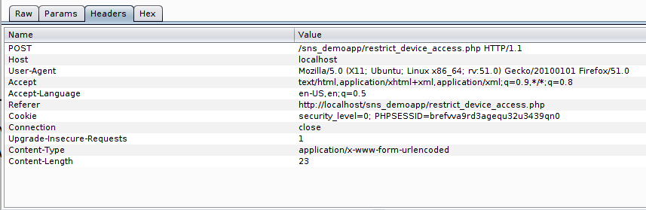

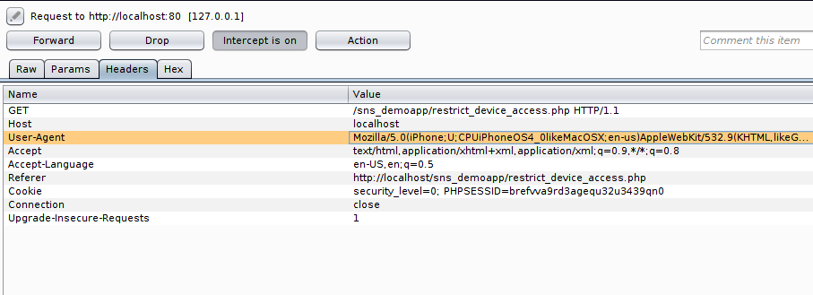

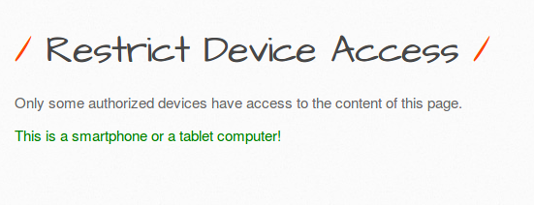

**Fixes:**

**Directory Traversal File:**

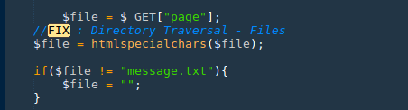

**Directory Traversal Directory:**

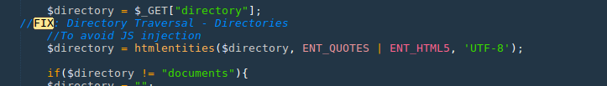

**Remote & Local File:**

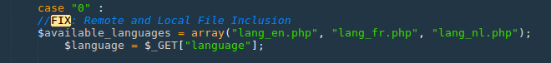

**A8 Cross Site Request Forgery**

**Change Password**



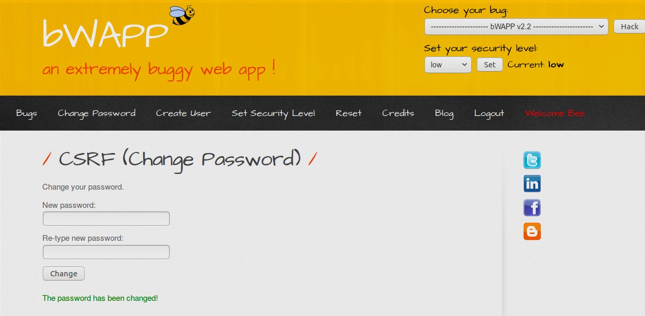

Defense

Use current password in form of user also for password change...which will be difficult for attacker to guess.

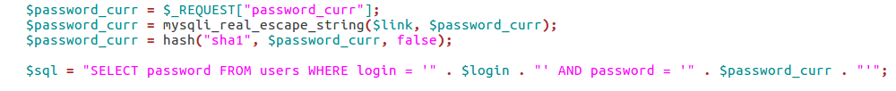

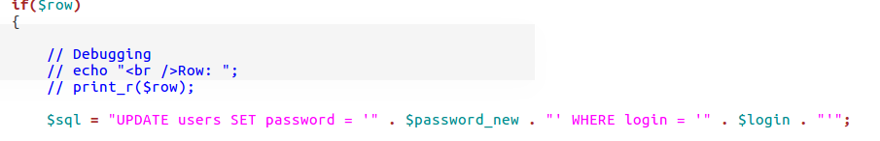

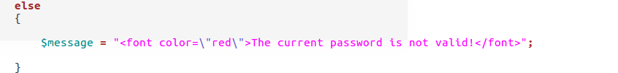

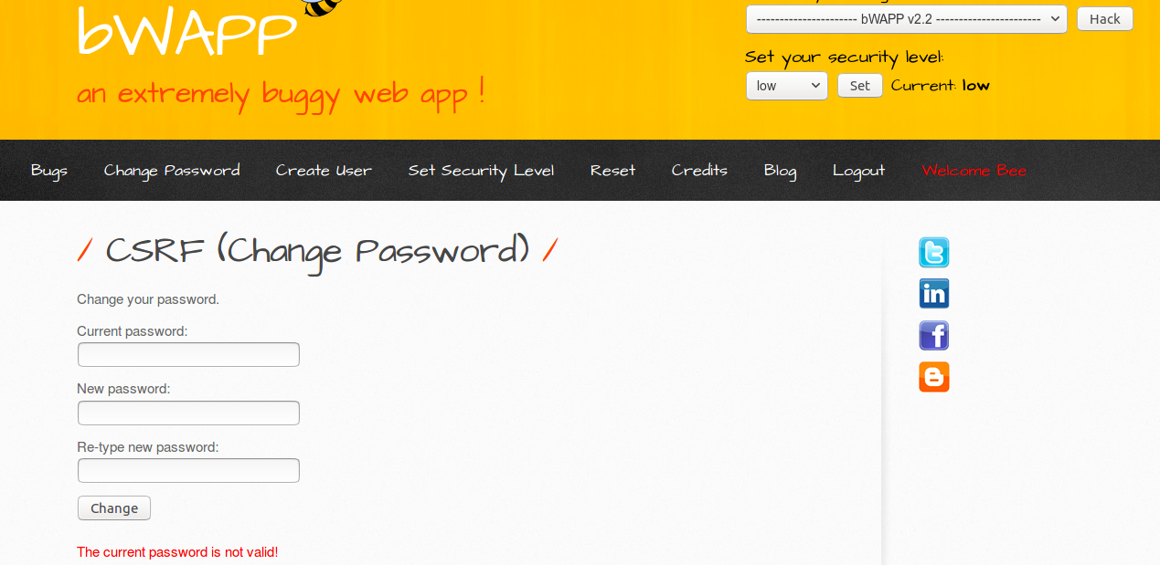

**Secret Change**

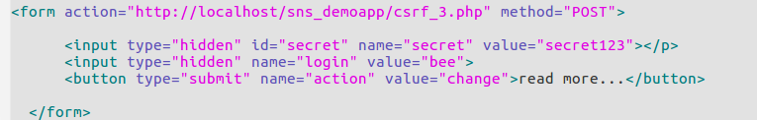

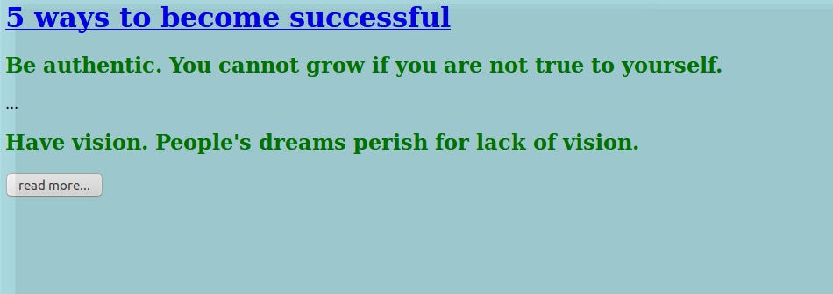

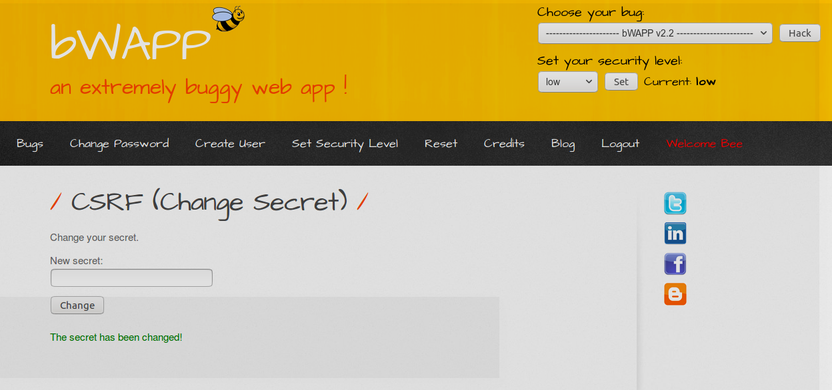

**Defense**

1.)Maintain a session token.

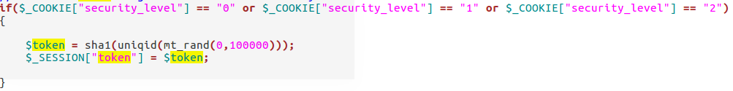

2.)Submit it everytime secret is changed.Attacker won’t have this token.



3.)Check this token everytime.

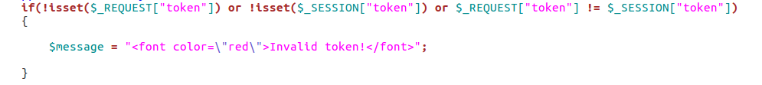

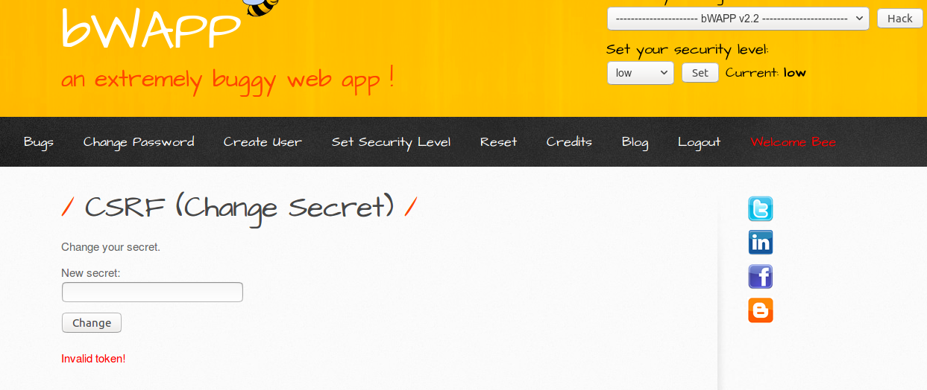

**Transfer Amount**





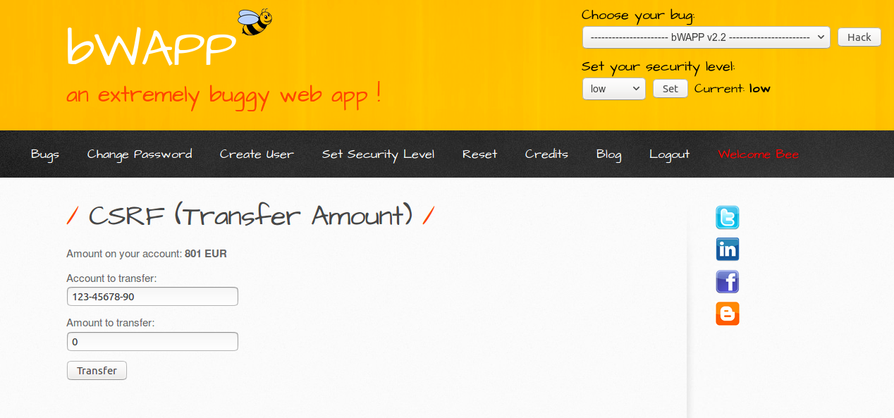

Defence

1.)Maintain a session token.



2.)Submit it everytime secret is changed.Attacker won’t have this token.



3.)Check this token everytime.



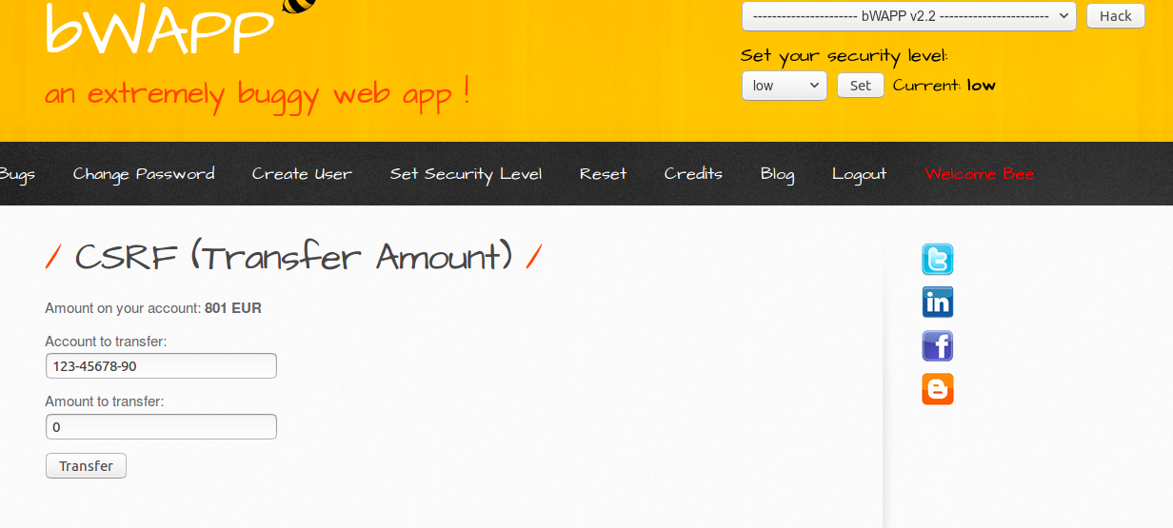

A9 Using Known Vulnerable Components

Php Eval Function

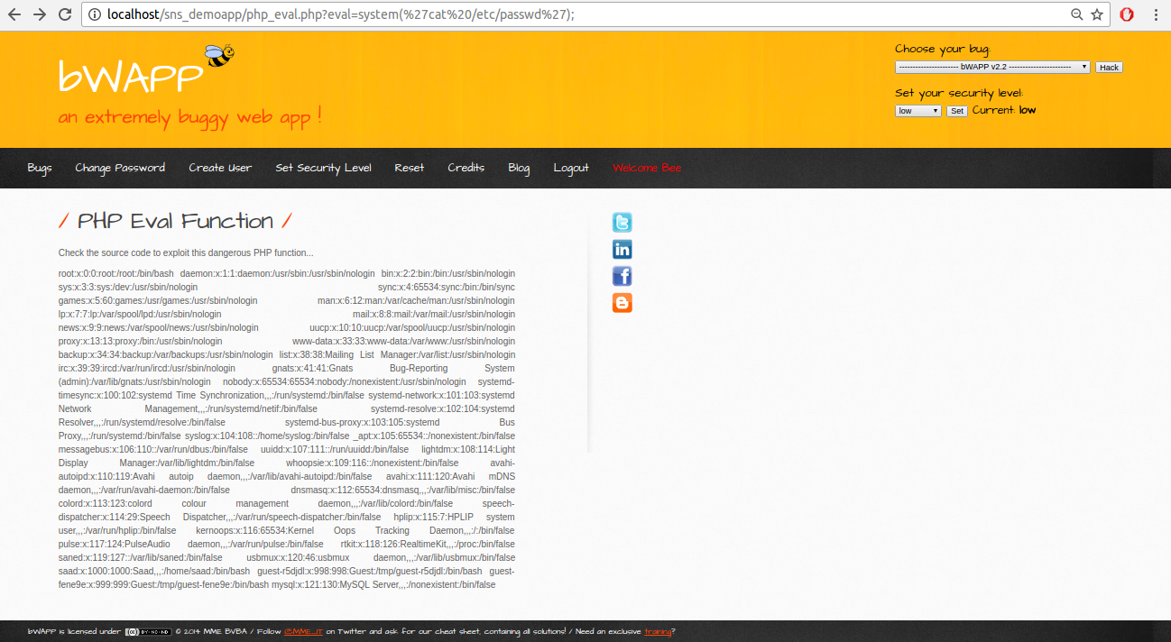

Buffer OverFlow

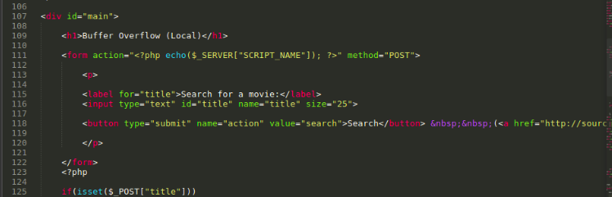

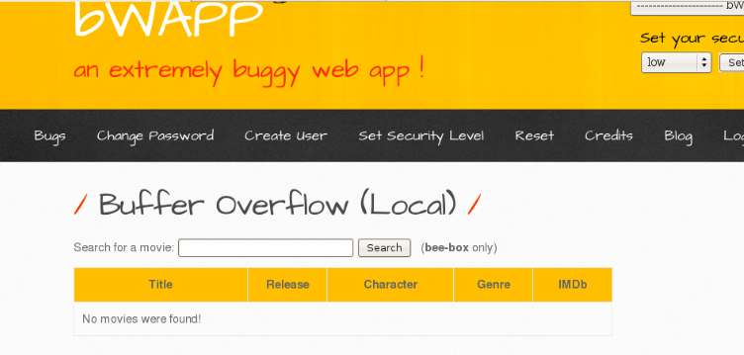

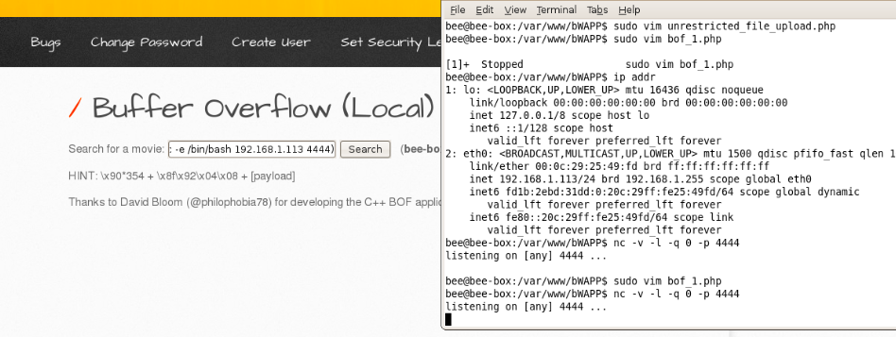

**Unrestricted File Upload**

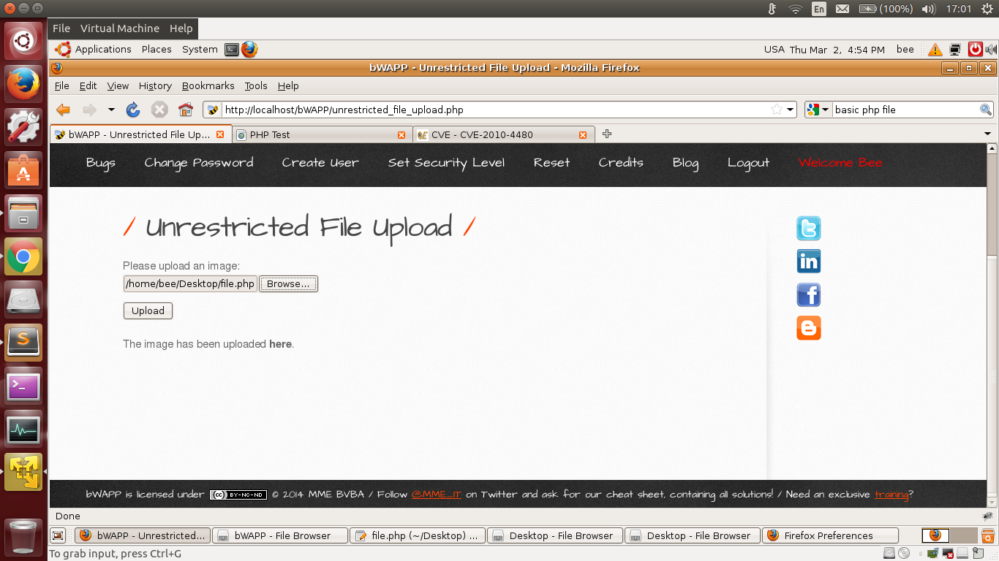

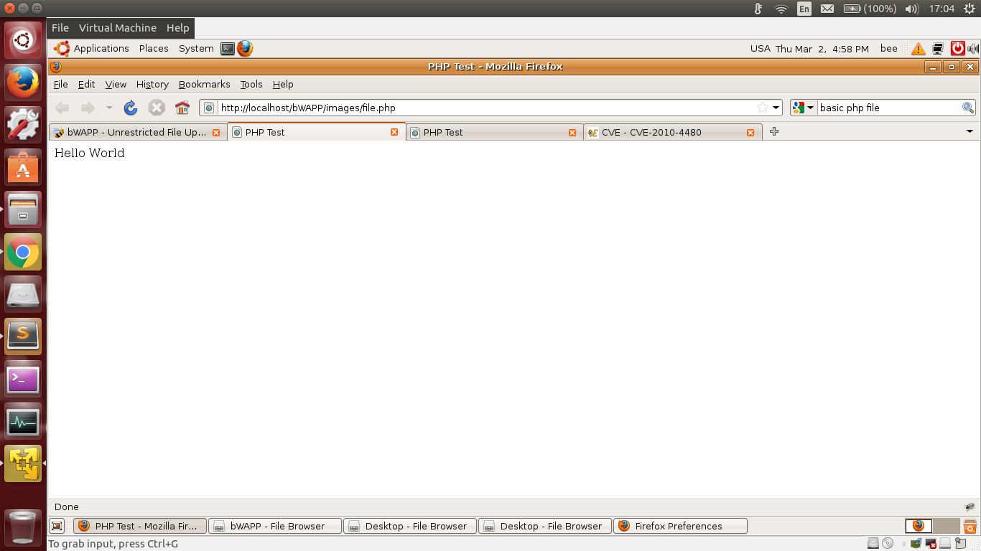

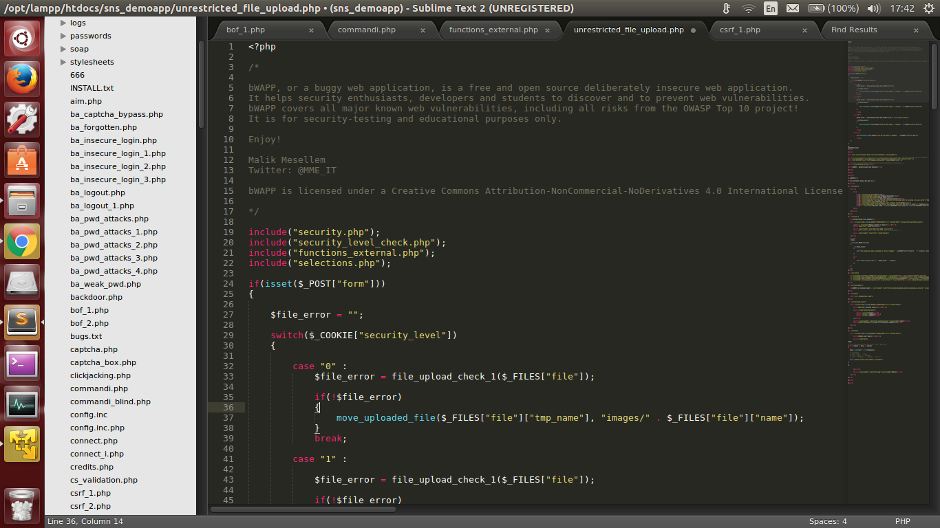

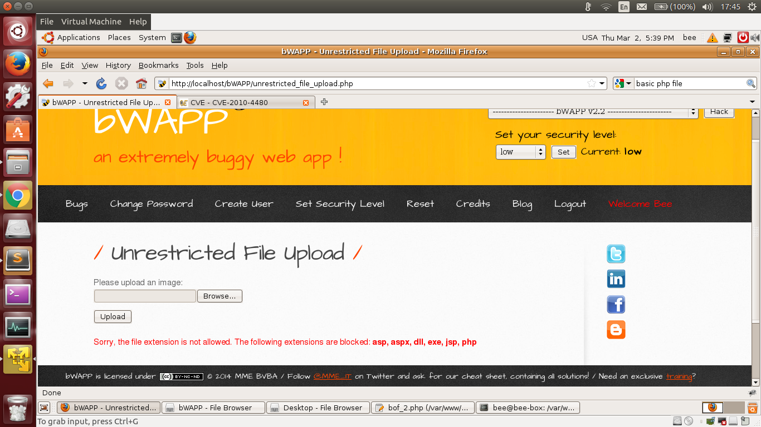

**Fixes:**

**Buffer OverFlow:**

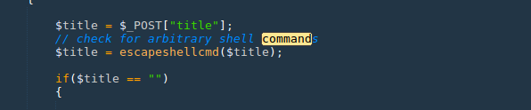

**Unrestricted File**

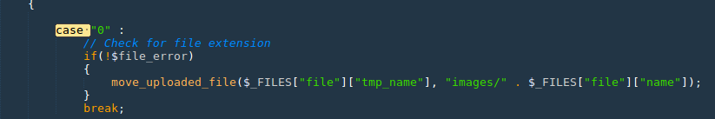

A10 Unvalidated Redirects and Forwards

